**Question 1: (CLO 3)**

**BAHRIA UNIVERSITY (KARACHI CAMPUS)**

**ASSGINMENT # 1 – SPRING 2021**

# Introduction to Software Engineering (SEN-120)

Class: **BSE 2(B)** **Submission Deadline: 29th March, 2020**

Course Instructor: **Engr. Mobeen Nazar** Max Marks:**10**

1. Many modern applications change frequently—before they are presented to the end user and then after the first version have been put into use. Suggest a few ways to build software to stop weakening due to change. **(5 Marks)  
     
   Suggestions:**It is reality that few current applications and the products have acquired the ability to dispose of the information or substance before the introduction of the application in front of the end user. The following are some ways which can stop the Weakening due to change  
   My advice is to talk to the end users at the beginning because sometimes something is prepared without discussion. In addition, one suggestion is to pay more attention to the plan and to be checked again. The initial design in some companies consists of some people it is better to involve more and more people on the front end. It will be better if you share the plans, you can catch the mistakes and it helps in the early stages. Some people will also give meaningless comments, but it is better It will be very difficult to follow the opinion, but it is beneficial for you. Must fight against stagnancy and politics and "need to know" policies to get more people involved, especially ones who have no power in the context of a company.  
     
   The applications of software must be maintainable.Software should have an option of automatic update.  
   Take feedback from the client at every step.

**Question 2: (CLO 3)**

Draw Workflow diagram of Online shopping system by using any online shopping platform as an example. **(5 Marks)**

**Online Shopping System  
Daraz.pk**  
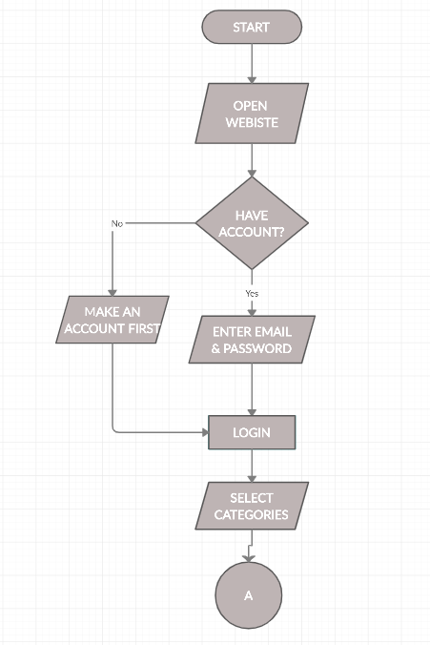  
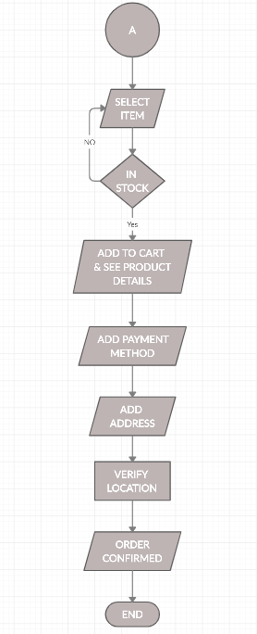

**Note**:

* If you submit your assignment after the given deadline then **2 Marks** will be deducted for the late submissions (i.e. 29th March, 2020) and after **29th March, 2020**, **Zero** will be awarded for those who would not be able to submit till then.
* Copied assignment will be marked **zero**.

Please submit these answers in hard copies and the deadline for BSE 2(A, B) is:

**29th March, 2020**